

Implementation guide on ABAP SDK for Azure

|  |  |  |  |
| --- | --- | --- | --- |
| **Version No.** | **Date** | **Name** | **Description of change** |
| 1.0 | MAY, 2018 | ABAP SDK for Azure | Initial version |
|  |  |  |  |

Table of Contents

1. Introduction 3

2. Prerequisite 3

3. Type of interface in Azure 3

4. Steps for sending data to Azure EventHub 3

4.1 Remote function call Destination Creation 4

4.2 SAP-Azure Data Framework Configurations 4

4.3 Usage of ABAP SDK for Azure EventHub 6

5. Dos and Don’ts on usage of ABAP SDK 8

6. Future Modification on implementation Guide 9

# Introduction

Intent of this document is to provide overview on the implementation of ABAP SDK for Azure ‘**EventHub**’ service. Azure Event Hubs is a highly scalable data ingress service that ingests millions of events per second so that you can process and analyze the massive amounts of data produced by your connected devices and applications. Once data is collected into an Event Hub, it can be transformed and stored using any real-time analytics provider or batching/storage adapters.

# Prerequisite

Installation of ABAP-SDK for Azure into your SAP system is required following the instruction of

[Installation guide of ABAP SDK for Azure](Link), for sending data to Azure EventHub.

# Type of interface in Azure

You can communicate to below Azure services through ABAP SDK.

* EVENTHUB - Azure EventHub Service
* BLOB - Azure Blob Service
* Document DB - service
* SERVICEBUS - Azure Servicebus
* AAD - Azure Active Directory
* KV- Azure Key vault

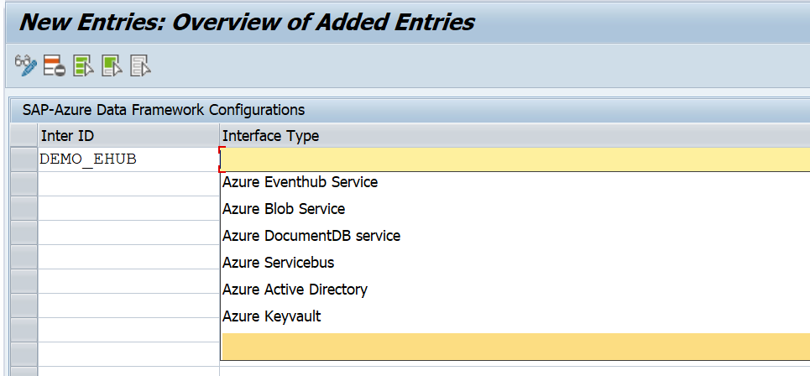

As part of initial version of implementation guide, follow the below steps to connect Azure EVENTHUB Service.

1. Steps for sending data to Azure EventHub

## 4.1 Remote function call Destination Creation

Create RFC destination in SAP (using transaction code SM59, Type ‘G’) as ‘HTTP connection to external server’ using the target host which you would receive from Azure Service team on getting subscription.

Details of configuration:

* RFC destination: AZUREEVENTHUB.
* Target Host: testhub.servicesbus.windows.net
* Path Prefix: /test123/messages

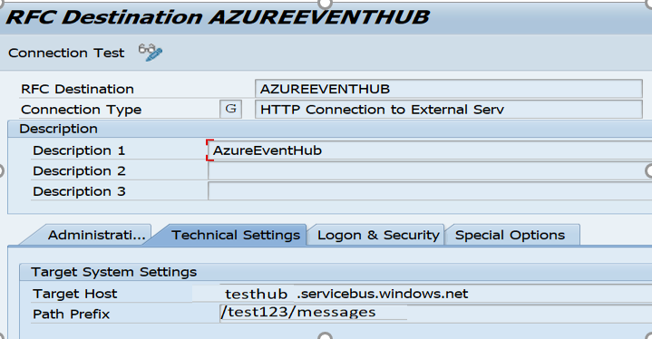

## SAP-Azure Data Framework Configurations

Create an interface Id ‘DEMO_HUB’ and maintain RFC destination ‘AZUREEVENTHUB’ in table ‘**ZREST_CONFIG’** (Configure Interface and RFC Destination) as shown below.

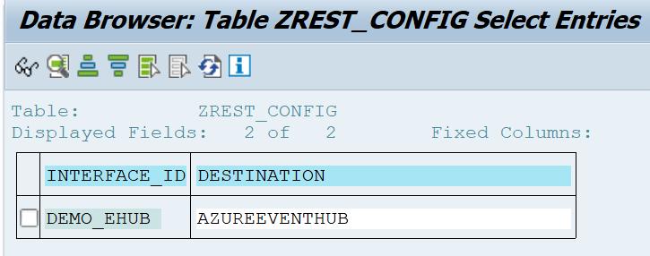

Create an entry in table ‘**ZREST_CONF_MISC’** for the above interface Id ‘DEMO_EHUB’.

Details of configuration:

* METHOD is ‘POST’.
* MAX_RETRY is number of retry in case of service failure.
* EMAIL_ID is the email id for sending alerts.
* MAIL_BODY_TXT is Text Id to be maintained for the mail content.
* RETRY_METHOD is type of retrial (Regular ‘0’ or exponential ‘1’).

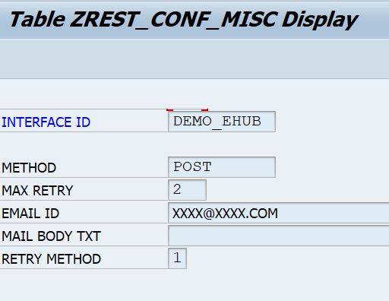

Create an entry in table ‘**ZADF_CONFIG’** for the above interface Id ‘DEMO_EHUB’.

Details of configuration:

* INTERFACE_TYPE is ‘EVENTHUB’.
* SAS_KEY is the shared key which you will receive from Azure team.
* URI is RFC destination Target host including path prefix of Azure EventHub to receive your data,
* SERVICE_TYPE can be synchronous(S) or asynchronous(A), maintain ‘S’ for synchronous communication.
* IS_TRY is a reprocessing flag, maintain as blank. However, it can be configured as ‘X’ for reprocessing in case of failure of services.

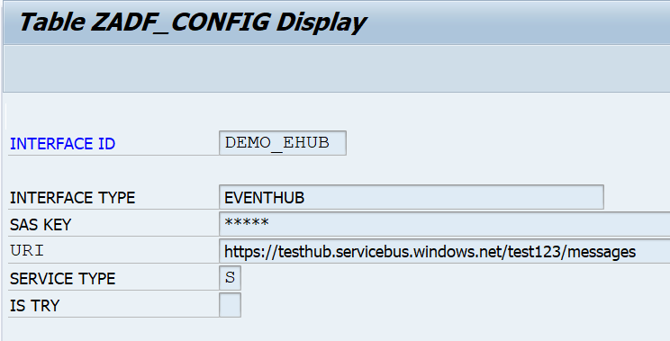

Create an entry in table ‘**ZADF_EHUB_POLICY’** for the interface Id ‘DEMO_EHUB’ to maintain policy ‘testpolicy’ assigned in Azure for the URI location. You can get policy namespace from Azure team.

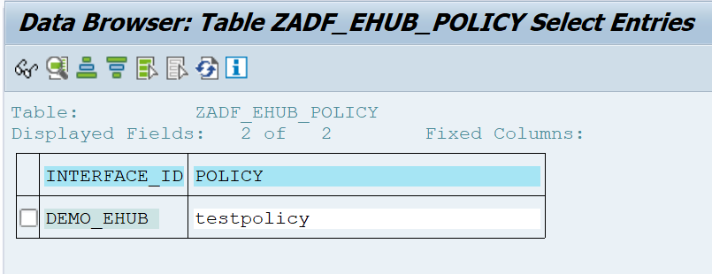

# 4.3 Usage of ABAP SDK for Azure EventHub

## 

*&---------------------------------------------------------------------*  
*& Report  ZDEMO_SEND_TO_EVENTHUB  
*& Sample program for using ABAP SDK to connect Azure Eventhub  
*&---------------------------------------------------------------------*  
REPORT ZDEMO_SEND_TO_EVENTHUB.

CONSTANTS: gc_interface TYPE zinterface_id VALUE 'DEMO_EHUB'.  
TYPES: BEGIN OF lty_data,  
          carrid    TYPE     s_carr_id,  
          connid    TYPE    s_conn_id,  
          fldate    TYPE    s_date,  
          planetype TYPE    s_planetye,  
          END OF lty_data.  
  
DATA:       it_headers        TYPE tihttpnvp,  
            wa_headers        TYPE LINE OF tihttpnvp,  
            lv_string         TYPE string,  
            lv_response       TYPE string,  
            cx_interface      TYPE REF TO zcx_interace_config_missing,  
            cx_http           TYPE REF TO zcx_http_client_failed,  
            cx_adf_service    TYPE REF TO zcx_adf_service,  
            oref_eventhub     TYPE REF TO zcl_adf_service_eventhub,  
            oref              TYPE REF TO zcl_adf_service,  
            filter            TYPE zbusinessid,  
            lv_http_status    TYPE i,  
            lo_json           TYPE REF TO cl_trex_json_serializer,  
            lv1_string        TYPE string,  
            lv_xstring        TYPE xstring,  
            it_data           TYPE STANDARD TABLE OF lty_data.  
  
*\*Sample data population for sending it to Azure eventhub*  
SELECT  
   carrid  
   connid  
   fldate  
   planetype  
 FROM sflight  
 UP TO 10 ROWS  
 INTO TABLE it_data.  
IF sy-subrc EQ 0.  
  
  TRY.  
*\*\*Calling Factory method to instantiate eventhub client*  
  
      oref = zcl_adf_service_factory=>create( iv_interface_id = gc_interface  
                                                         iv_business_identifier = filter ).  
      oref_eventhub ?= oref.  
  
*\*\*Setting Expiry time*  
      CALL METHOD oref_eventhub->add_expiry_time  
        EXPORTING  
          iv_expiry_hour = 0  
          iv_expiry_min  = 15  
          iv_expiry_sec  = 0.  
  
      wa_headers-name = 'path_prefix'.  
      wa_headers-value = '/test123/messages'.  
      APPEND wa_headers TO it_headers.  
      CLEAR  wa_headers.  
  
      CREATE OBJECT lo_json  
        EXPORTING  
          data = it_data.  
      lo_json->serialize( ).  
      lv1_string  = lo_json->get_data( ).  
  
  
*\*Convert input string data to Xstring format*  
      CALL FUNCTION 'SCMS_STRING_TO_XSTRING'  
        EXPORTING  
          text   = lv1_string  
        IMPORTING  
          buffer = lv_xstring  
        EXCEPTIONS  
          failed = 1  
          OTHERS = 2.  
      IF sy-subrc <> 0.  
      ENDIF.  
*\*\*Sending Converted SAP data to Azure Eventhub*  
      CALL METHOD oref_eventhub->send  
        EXPORTING  
          request        = lv_xstring  *"Input XSTRING of SAP Business Event data*  
          it_headers     = it_headers  *"Header attributes*  
        IMPORTING  
          response       = lv_response       *"Response from EventHub*  
          ev_http_status = lv_http_status.   *"Status*  
    CATCH zcx_interace_config_missing INTO cx_interface.  
      lv_string = cx_interface->get_text( ).  
      MESSAGE lv_string TYPE 'E'.  
    CATCH zcx_http_client_failed INTO cx_http .  
      lv_string = cx_http->get_text( ).  
      MESSAGE lv_string TYPE 'E'.  
    CATCH zcx_adf_service INTO cx_adf_service.  
      lv_string = cx_adf_service->get_text( ).  
      MESSAGE lv_string TYPE 'E'.  
  ENDTRY.  
  IF lv_http_status NE '201' AND  
     lv_http_status NE '200'.  
    MESSAGE 'SAP Event data not sent to EventHub client' TYPE 'E'.  
  ELSE.  
    MESSAGE 'SAP Event data sent to EventHub client' TYPE 'S'.  
  ENDIF.  
  
ELSE.  
  MESSAGE 'No data found' TYPE 'E'.  
ENDIF.  *" If data present.*

# Dos and Don’ts on usage of ABAP SDK

ABAP SDK is primarily designed for real time eventing data from SAP to Azure EventHub as per initial version. This shouldn’t be used for huge volume of data in a batch processing as several parallel processing approaches are required explicitly to handle the bulk volume of data processing which has not been considered in the current version of ABAP SDK library.

# Future Modification on implementation Guide

This implementation guide has shown the steps for implementing Interface to Azure Event Hub, In successive versions we will publish guide on connecting to all other Azure Services like Blob, Servicebus, Cosmos DB, Azure Active directory and Azure key vault.